Proposal to FFplus Project Call-1 – Type-2: Innovation Studies for the Development of Generative AI Models

Part A
Call Information:
Identifier: FFplus_Call-1-Type-2
Call title: First call for innovation studies for the development of generative AI models
Project full name: Fortissimo Plus
Acronym: FFplus
EuroHPC Project 101163317
Deadline: September 4th, 2024, at 17:00 Brussels local time

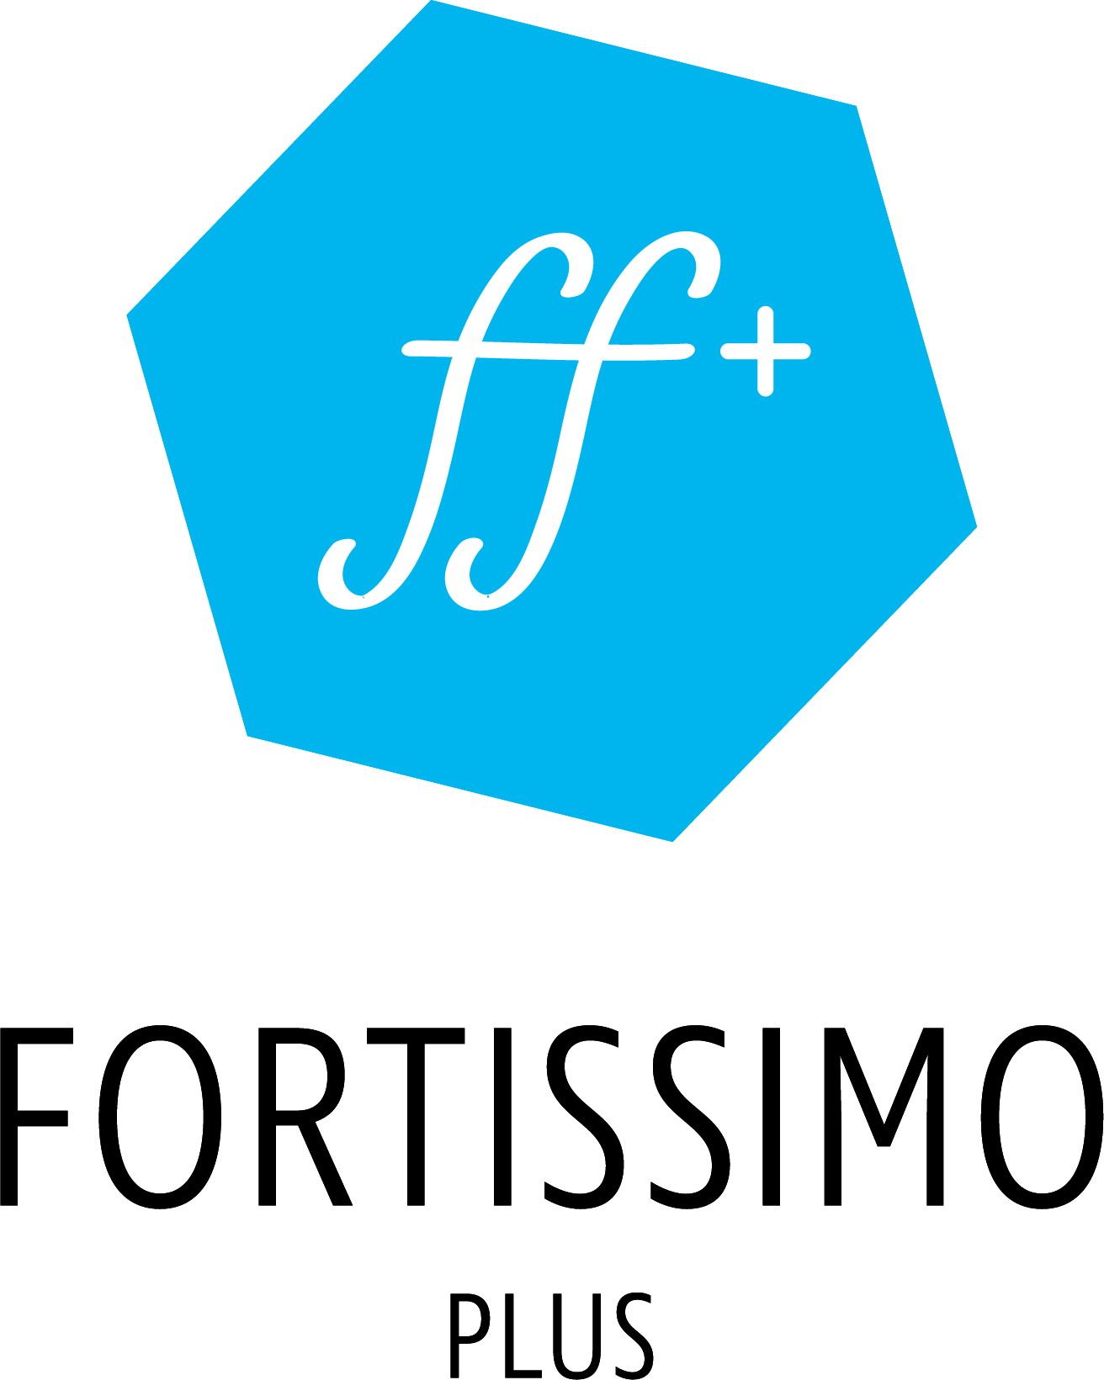

  - Innovation Study Title

Name of the coordinating person:
Title First Name, Last Name, Partner Organisation
E-mail:

No. | Participant organisation name | Participant short name | Country
1
2
3

No. | Participant short name | SME (yes/no) | PIC | Role in the Consortium  (Main Participant, Application Expert, HPC Expert, Other)
1
2
3

Were similar or related activities (*) funded through other European Commission or national research project funding?
☐ Yes
☐ No
If yes: please provide details (project name and funding programme).

Feedback to the project
In order to better support the general broadening of SME exploitation of HPC services and technologies, FFplus plans to organise a number of surveys to identify and collect SMEs needs. Please indicate if you would be willing to be approached and provide responses to such surveys:
☐ Yes
☐ No
It should be noted, that the response to this question has absolutely no influence on the evaluation of the proposal.

How did the Consortium participants become aware of the FFplus Open Call?
(Please tick all options that apply)
☐ | FFplus Web-site
☐ | Electronic Media | Please list:
☐ | Webinars and presentations | Please list:
☐ | Other media | Please describe
☐ | Personal Contacts | Please describe
☐ | Other | Please describe

Statistical Information

1 Participant (Organisation name) | 2 Country | 3 Type (SME /MID /IND / AC / OTHER) | 4 First EU project? (Y/N) | 5 PIC | 6 Funding requested | 7 Total costs
TOTAL

Notes
[Please delete these notes in the submitted version]
- Participant: Insert the name of the organisation. Please start with the coordinating partner
- Country: Insert the 2-letter country code (using the Eurostat country codes: http://ec.europa.eu/eurostat/statistics-explained/index.php/Glossary:Country_codes).
- Type: Insert
  - SME for an SME (in particular, independent enterprise with max 250 employees and 50 M€ annual turnover, cf.
http://ec.europa.eu/growth/smes/business-friendly-environment/sme-definition_en),
  - MID for a mid-cap enterprise (max 2000 employees and 400 M€ annual turnover),
  - IND for large industrial enterprise,
  - AC for academia (universities and research institutes),
  - OTHER for any other organisation type (e.g. governmental agencies, industry consortia etc.)
- Fill in Y if this would be the first European project for that partner, N otherwise.
- Provide the PIC number here if available.
- Specify the requested funding in Euros (0 decimal places).
- Specify the total costs in Euros (0 decimal places)
- Row TOTAL: Please sum up both the requested funding & costs in the columns above

Participant Identification Code (PIC): To obtain a PIC, register at https://ec.europa.eu/info/funding-tenders/opportunities/portal/screen/how-to-participate/participant-register . Please note that having a PIC is not a requirement of the call.
Participant Identification Code (PIC): https://ec.europa.eu/info/funding-tenders/opportunities/portal/screen/how-to-participate/participant-register .
i.e. rounded to the nearest Euro

