Proposal to FFplus Project Call-1 – Type-2: Innovation Studies for the Development of Generative AI Models

Part B
Call Information:
Identifier: FFplus_Call-1-Type-2
Call title: First call for innovation studies for the development of generative AI models
Project full name: Fortissimo Plus
Acronym: FFplus
EuroHPC Project 101163317
Deadline: September 4th, 2024, at 17:00 Brussels local time
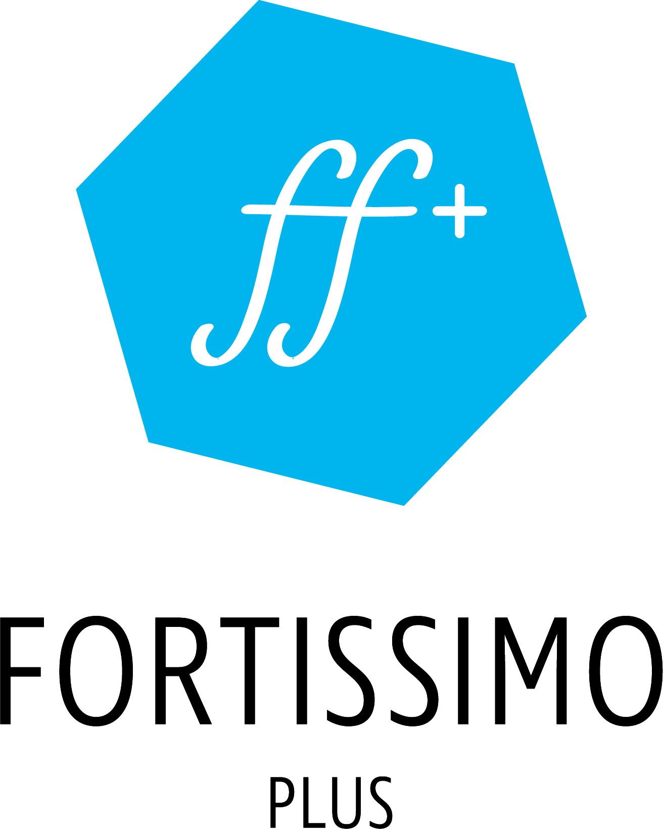

  - Innovation Study Title

Name of the coordinating person:
Title First Name, Last Name, Partner Organisation
E-mail:

This cover page may not be extended with any additional text/information.
This cover page will be ignored when the page count of the proposal is checked.

Summary
(Guideline: 0.5 pages)

Industrial relevance, potential impact and exploitation plans
(Guideline: 3.5 pages)
FFplus_Call-1-Type-2 targets proposals for “innovation studies” driven by the business needs of SMEs and Start-ups highly competent in generative AI, professional software development, and data processing. The innovation studies must use large-scale European HPC resources (e.g., pre-exascale and exascale supercomputers) to develop and customise generative AI models such as foundation and large language models.
- Specify if the SME (main participant) has an existing business model that significantly benefits from the development of generative AI models, HPC awareness or experience.
- Clearly define the business problem at hand and explain how why generative AI serves as a solution to the business problem or business prospect, why the development of a new model is imperative and why this could not be addressed sooner.
- Explain the expected business impact and potential value propositions and the process of value creation.

Description of the work plan, technological/algorithmic approach and software development strategy
(Guideline: 5 pages)
- Define specific objectives that must be achieved to successfully address the business problem and the accompanying action plan described in terms of an ML lifecycle.
- Provide a detailed description and demonstrate the availability of a suitable training data set.
- Detail the characteristics of the models to be developed and outline their repercussions to training and exploitation.
- Explain performance metrics, describe benchmarks to establish baselines and specify methods to ensure experiment reproducibility.
- Identify potential risks considering EU guidelines for trustworthy AI and present means to address and mitigate them.
For the work plan:
- Include the delivery of a pre-final results and potential impact report: It is a requirement of all innovation studies that they deliver an intermediate report on the results achieved (and those expected by the end of the study) and the potential impact of those results on the SME’s business model and potentially by third parties using the results. This report is to be delivered by the end of the 7th month. It will be used to evaluate the eligibility to submit a proposal for extension/continuation of the innovation study to a subsequent open call for proposals.
- Present a data management plan that covers policies for data access, usage, sharing, retention, and disposal; outlines methods for protecting sensitive or personal data; and incorporates FAIR principles and their implementation when applicable

Experiment Title
Participant short name
Role
Description:

Workplan
Task 1 Task name
Task description.
Deliverable: Deliverable short description (Innovation Study Month nn (i.e. within months 1 to 10 of the innovation study))

Impact and Outputs
(Output = concrete results from the innovation studies, such as, but not limited to, business case analyses/reports, software releases, user workflows, experience reports,..
Impact = explanation of the use of innovation study results and the related business impact, enhanced capabilities or potential for service offerings, etc.)

The output of the innovation study will be:

The results of the innovation study will be …

Participants and effort
Participant |  |  |  |  |  | TOTAL
Effort (PM)
PM = Person Months

Quality of the consortium as a whole and of the individual proposers
(Guideline: 1-2 pages)

A main participant is an SME or a Start-up and supporting participants are organisations assisting the main participant to complete activities foreseen for the innovation study. Proposals are to be submitted by the main participant who must provide a business case/challenge and optionally (if well justified) up to two supporting participants. Each consortium partner needs to have a clearly defined role.
The descriptions of the individual proposers should explain the proposer’s capability, as an entity and, in terms of the key staff to be assigned to the experiment, to carry out the proposed action, considering strategic and operational processes, and the assigned tasks. The description of the consortium (for the innovation study) as a whole should provide evidence that the consortium includes the necessary and sufficient set of complementary capabilities (i.e. no unnecessary overlap of capabilities nor omission of required capabilities). Specify if the SME (main participant) has qualified staff with the necessary expertise in generative AI, software development, technical project management, and data processing
For supporting participants, only engineering activities are eligible for funding. Activities such as business consultancy, marketing initiatives, administrative tasks, and other non-engineering activities are not eligible for funding.

Justification of costs and resources
(Guideline: 1-2 pages)
- Clearly explain the HPC resources (hardware, software, frameworks, and compute volumes) appropriate for the execution of the innovation study. Define the HPC resources needed, possibly using computing resources provided directly (free of charge) by the EuroHPC JU, e.g. through their AI and Data-Intensive Applications Access system, or through national actions.
- Demonstrate how the allocated resources (personnel, IT/computing and any other resources) address and fill current gaps in the processes needed to implement the proposed action.
Cost breakdown per Participant; Funding for Third Parties;
(The table below is an embedded spread-sheet, please use it, by double-clicking the table, to input your data. The data in the spread-sheet is purely for illustration purposes)
Costs for subcontracting and other direct costs, including computing costs need to be clearly explained. Indirect costs are not eligible for Funding for Third Parties.

A main participant is an SME or a Start-up and supporting participants are organisations assisting the main participant
https://ec.europa.eu/newsroom/dae/document.cfm?doc_id=60419
Examples of roles: SME, application expert, HPC expert

